- For the examples perform the following:
- Draw a state transition diagram
- Determine the level of coverage
- Make a state transition table from the diagram
- Define logical test cases

- Two-speed electric toothbrush
- A two-speed electric toothbrush is operated by pressing its one button
- The ﬁrst press of the button turns the toothbrush from off to speed one, the second press of the button turns it to speed two
- When the button is pressed for a third time the electric toothbrush is turned off

State | Event | Action | New state
OFF | Remain turned off | Press button | Speed I
Speed I | Start work on speed I | Press button | Speed II
Speed II | Start work on speed II | Press button | OFF

- Tape player
- A tape player has three operations: play, fast forward and fast play.
- Play and fast forward are activated using the play and fast forward button respectively. These operations can be cancelled using the stop button. When in play mode, the fast forward can be used to fast play. When in fast play mode, the fast forward button can be pressed again to enter fast forward or the stop button can be used to return to play. When in fast forward the play button can be pressed to enter play mode directly.
Make 0-switch and 1-switch coverage.

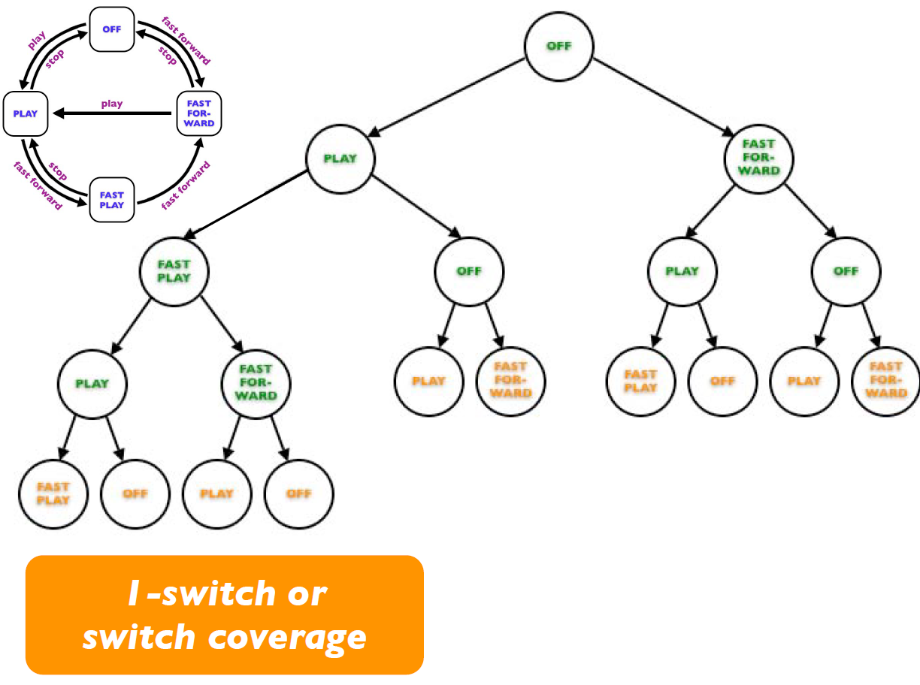
I – switch logical test cases for the tape player:
Test 1:
 | Step 1 | Step 2 | Step 3 | Step 4
Start state | OFF | Play | Fast play | Play
Input | Press play | Press fast forward | Press stop | Press fast forward
Output | Play | Fast play | Play | Fast play
Finish state | Play | Fast play | Play | Fast play

Test 2:
 | Step 1 | Step 2 | Step 3 | Step 4
Start state | OFF | Play | Fast play | Play
Input | Press play | Press fast forward | Press stop | Press stop
Output | Play | Fast play | Play | OFF
Finish state | Play | Fast play | Play | OFF

Test 3:
 | Step 1 | Step 2 | Step 3 | Step 4
Start state | OFF | Play | Fast play | Fast forward
Input | Press play | Press fast forward | Press fast forward | Press play
Output | Play | Fast play | Fast forward | Play
Finish state | Play | Fast play | Fast forward | Play

Test 4:
 | Step 1 | Step 2 | Step 3 | Step 4
Start state | OFF | Play | Fast play | Fast forward
Input | Press play | Press fast forward | Press fast forward | Press stop
Output | Play | Fast play | Fast forward | OFF
Finish state | Play | Fast play | Fast forward | OFF

Test 5:
 | Step 1 | Step 2 | Step 3
Start state | OFF | Play | OFF
Input | Press play | Press stop | Press play
Output | Play | OFF | Play
Finish state | Play | OFF | Play

Test 6:
 | Step 1 | Step 2 | Step 3
Start state | OFF | Play | OFF
Input | Press play | Press stop | Press fast forward
Output | Play | OFF | Fast forward
Finish state | Play | OFF | Fast forward

Test 7:
 | Step 1 | Step 2 | Step 3
Start state | OFF | Fast forward | Play
Input | Press fast forward | Press play | Press fast forward
Output | Fast forward | Play | Fast play
Finish state | Fast forward | Play | Fast play

Test 8:
 | Step 1 | Step 2 | Step 3
Start state | OFF | Fast forward | Play
Input | Press fast forward | Press play | Press stop
Output | Fast forward | Play | OFF
Finish state | Fast forward | Play | OFF

Test 9:
 | Step 1 | Step 2 | Step 3
Start state | OFF | Fast forward | Off
Input | Press fast forward | Press stop | Press play
Output | Fast forward | OFF | Play
Finish state | Fast forward | OFF | Play

Test 10:
 | Step 1 | Step 2 | Step 3
Start state | OFF | Fast forward | Off
Input | Press fast forward | Press stop | Press fast forward
Output | Fast forward | OFF | Fast forward
Finish state | Fast forward | OFF | Fast forward

- Simple electronic clock
- A simple electronic clock has four modes: display time, change time, display date and change date
- The change mode button switches between display time and display date
- The reset button switches from display time to adjust time or display date to adjust date
- The set button returns from adjust time to display time or adjust date to display date
Make 0-switch and 1-switch coverage.

